SAMAY KE GHUNGROO
A Journey Through the Evolution of Kathak
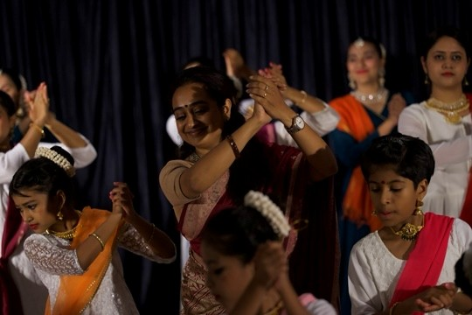
Partnership Proposal

About AartShaala
Aartshaala was established in 2014 with the objective of creating a serious and accessible learning environment for Kathak and Indian folk dances students.
Over the years, the institution has engaged more than 400 students through regular
training, workshops and performance opportunities across India and internationally. The Bangalore chapter was established in 2022 and currently trains over 45 students.
The focus at Aartshaala is simple: strong fundamentals, disciplined learning and meaningful performance experiences. Students are encouraged to develop technical proficiency while building confidence, commitment, a sense of community and an appreciation for performing arts.
Today, Aartshaala continues to operate as a growing community of students, parents and art enthusiasts brought together by a shared interest in learning and experiencing Kathak.
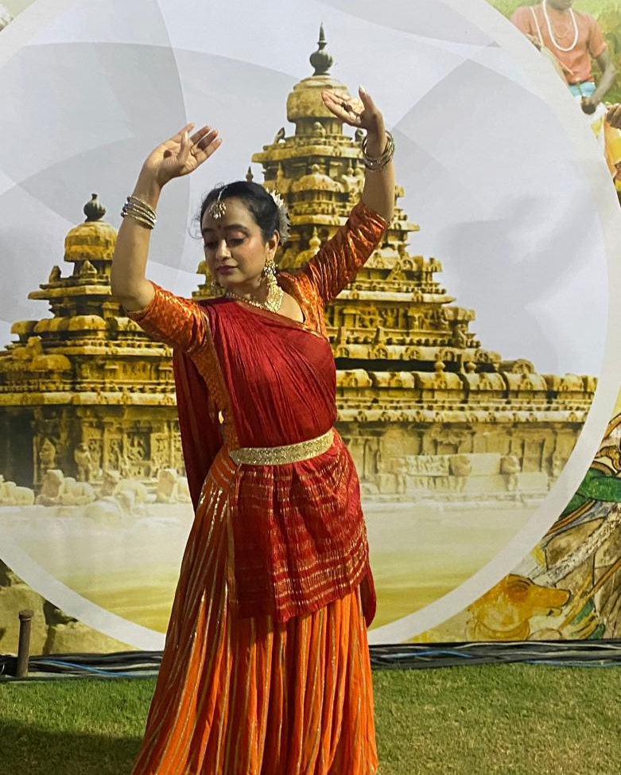
About the Founder
Rupini Raman is a senior Human Resources leader, Kathak artist and founder of Aartshaala.
A student of Kathak for over three decades, she has pursued her artistic journey alongside a full-time corporate career, balancing leadership responsibilities with rigorous training, performance and teaching.
She is a Doordarshan Graded Artist, holds a Bachelor's Degree in Kathak and is currently pursuing her Master's Degree in the discipline.
In 2014, she founded Aartshaala with the intention of creating a structured and nurturing environment for students interested in learning Kathak. Over the last decade, she has trained and mentored hundreds of students through regular classes, workshops and stage productions.
Her belief is straightforward: while careers and professional identities are important, every individual benefits from having an artistic pursuit in life. Art develops discipline, focus, confidence and creativity, and often becomes a lifelong source of joy and personal fulfilment.
Through Aartshaala, she hopes to make that experience available to more students and families.
About the Production - Samay Ke Ghungroo
Samay Ke Ghungroo is Aartshaala's annual showcase, the first in Bangalore. This year's theme explores the evolution of Kathak through time.
Through dance, music and storytelling, students will present Kathak's journey from its origins as a storytelling tradition to its development through royal courts and its expression on contemporary stages today.
The production is an opportunity for students to experience the discipline and excitement of presenting a professional performance while deepening their understanding of the history and heritage of the art form they learn.
Event Details
Venue | Bangalore International Centre (BIC)
Audience: | Approximately 180 invited guests
The audience will include:
• Families and parents • Cultural enthusiasts
• Professionals and entrepreneurs
• Educators and artists • Members of Bangalore's arts community
The event brings together individuals who value learning, culture, tradition and community.
Aartshaala at a Glance
• 400+ students engaged through regular training and workshops
• Students across India and internationally
• 2006 Annual showcase hosted at Bangalore International Centre
• Founded and led by Rupini Raman, Doordarshan Graded Artist
• Dedicated to making Indian classical arts accessible to the next generation
• Focused on learning, performance and cultural appreciation through Kathak
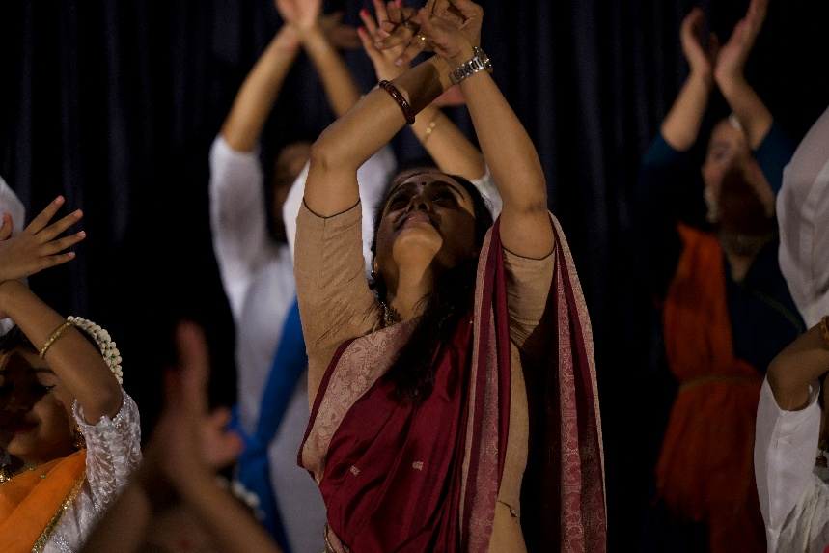
Why This Matters
In an increasingly fast-paced world, opportunities for young people to engage deeply with the arts are becoming fewer.
Yet art continues to play an important role in shaping confidence, creativity, discipline and self-expression. It keeps us connected to our roots while helping us navigate a rapidly changing world.
Not every child who learns an art form will become a professional artist, nor should that be the goal. However, every child can benefit from the experience of learning, practising and appreciating an art form.
Samay Ke Ghungroo seeks to create that opportunity – allowing students to learn from tradition, perform with confidence and experience the joy of being part of something larger than themselves.

Partnership Opportunities
We invite individuals and organisations who value education, culture and community to support this initiative.
Patron Partner/ Platinum Sponsor
Contribution: ₹75,000
• Principal acknowledgement across event communications
• Premium visibility in event brochure, passes
• Acknowledgement during the event
• Foyer standee placement
• Reserved seating for guests

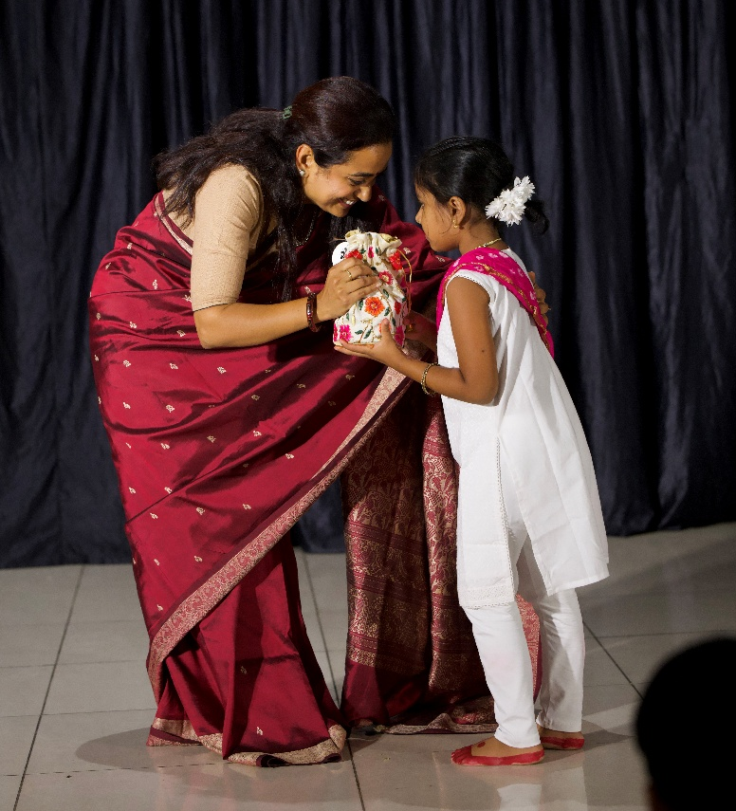
Cultural Partner/ Gold Sponsor
Contribution: ₹40,000
• Visibility in event brochure
• Acknowledgement during the event
• Foyer standee placement
• Reserved seating

Supporting Partner
Contribution: ₹20,000
• Visibility in event brochure
• Acknowledgement during the event
• Reserved seating

A Personal Note
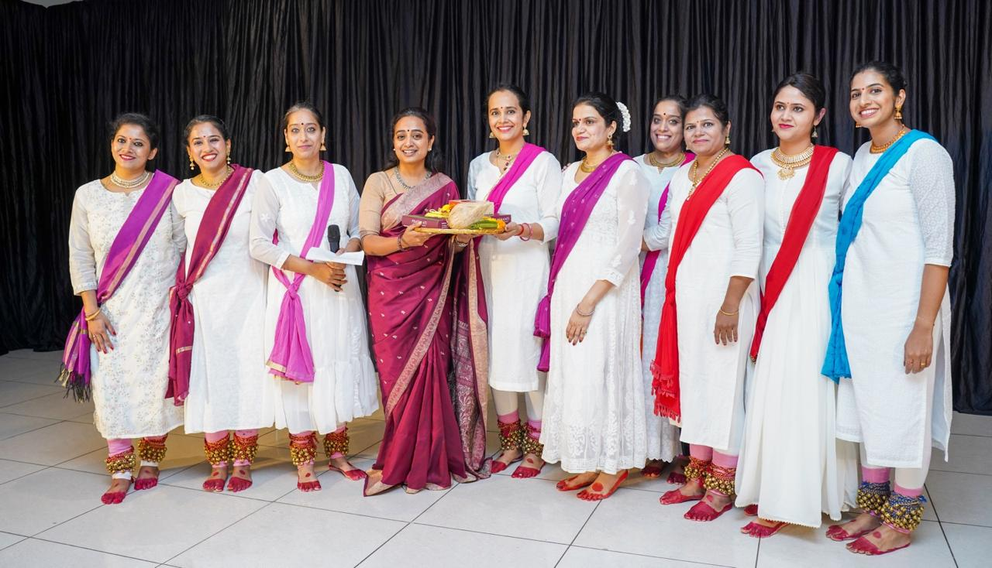
Aartshaala is a labour of love that has grown steadily over the last decade alongside my professional career.
As someone who has spent many years in corporate leadership while continuing my own journey as a student and practitioner of Kathak, I have experienced the value that an artistic pursuit brings to life.
Not every student who learns Kathak will become a performer, and that is perfectly fine. The objective is not to create professional dancers out of everyone. It is to give young people an opportunity to learn, commit to something meaningful and experience the confidence that comes from mastering a craft.
If this vision resonates with you, we would be grateful for your support.

With gratitude,
Rupini Raman
Founder, Aartshaala
Kathak Artist and Teacher | Doordarshan Graded Artist

